

***Progress Report: Capacity development on mainstreaming disaster risk reduction and climate change adaptation into national and provincial plans and programmes in Mozambique (2013-2016)***

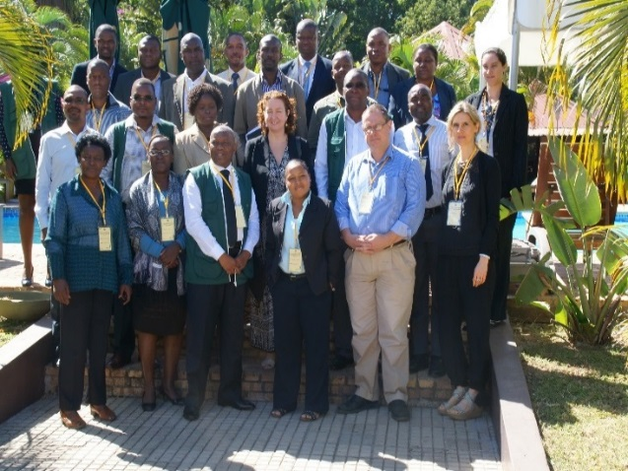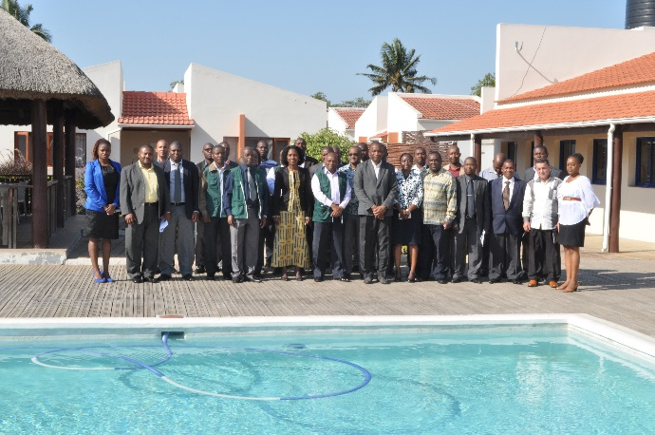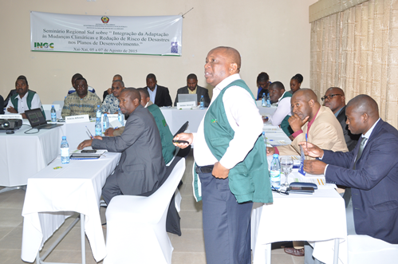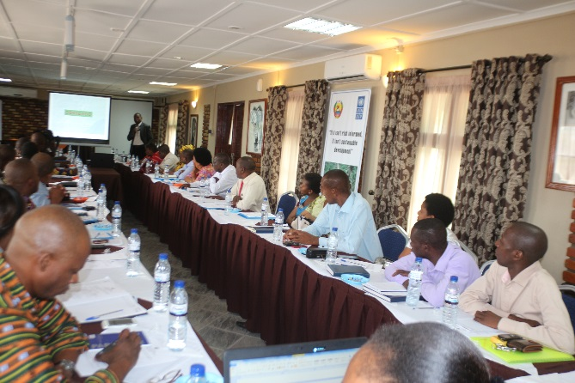

**Annual Report 2015**

**Background**

In response to the vulnerability of Mozambique to disasters, disaster risk reduction and climate change adaptation have become a key concern for the Government of Mozambique (GoM). Recognizing that the country’s persistent disaster impacts and their related consequences on household livelihoods need to be urgently addressed if the nation is to make progress towards poverty alleviation and the attainment of the MDGs. The Government has made firm commitments to mainstreaming disaster risk reduction, climate change adaptation and gender into development as a priority. Such commitment is reflected in the Poverty Reduction Strategy Plan (PARP) 2012 – 2015, and the recently approved National Climate Change Strategy (2013-2018). It also recognizes the key role that disaster risk reduction plays in adapting to current challenges from hazards and has established the National Institute for Disaster Management (INGC) which is mandated among others to develop the needed measures towards preventing /mitigating disasters and responding to the plight of disaster victims when they do occur.

As part of the UNDP’s support to the government on disaster risk management and climate change adaptation, a project was designed with funds from BCPR to support the government agenda in building resilient communities to disasters and climatic changes. The project seeks to support government institutions, civil society and the general population to reduce disaster risk within the country and to adapt to the negative effects of climate change, in order to protect development gains for the country as a whole, and especially for those most vulnerable. To make contributions to the achievement of the above, the project is concentrating on 3 different thematic areas, in line with the UNDAF outputs, focusing on: 1) National capacity on mainstreaming DRR/CCA into national and provincial policies and programmes enhanced; 2) Disaster and climate risk information systems improved; 3) National and provincialsystems for recovery strengthened.

An amount of USD 1, 670,000was sought for with USD1, 110,000 expected from BCPR, and USD 300,000 from the SWISS. Though the entire project was approved in September 4, 2013 by BCPR, a total amount of USD 200,000 was made available from BCPR with the SWISS contribution of USD300, 000. UNDP also contributed USD260, 000 from its core resources to support the activities.

Implementation of activities started in second quarter of 2014 after signing the work plan with INGC in January 29, 2014. The delays were primarily due to the government’s focus on preparedness for the floods and cyclone season, usually expected from January to April each year. Prior to the season November and December are devoted for preparation of contingency plans and simulation exercise to correct defects before the emergency season begins. Though there were moderate floods for the 2013/2014 season, these could be managed in-country. Summary of activities implemented up-to-date are noted below under each output.

BCPR/BPPS made an allocation of 500,000USD in 2015

**Output 1: National capacity for mainstreaming DRR/CCA into national and provincial policies and programmes enhanced.**

Project achievements in 2015 include:

**i) Mainstreaming of DRR and CCA into sector plans**: Following the introduction of the MADRiD initiative by UNDP/UNISDR, to peer leaders in-country, 2013, interest in the subject area has risen where the peer leaders advocated for embracement of the initiative. With resources made available in 2013 under this project, a number of workshops have been held across the country. The target audience include decision makers, directors of government sectors, planning directors, and technicians from the provincial and district levels. While the main aim with decision makers is to raise their commitment in driving the process of DRR/CCA mainstreaming, the main objective with the other target groups is to ensure that they are equipped with skills and knowledge on DRR/CCA mainstreaming.

A total of five in-country and one regional trainings have been conducted under this project. The national trainings were conducted in the three regions (South, Central and North) of the country where participants were drawn from the provinces. In all, 243 persons (185 men and 58 women) have been trained across the country in the regions. A number of trainings are planned to cascade the initiative to the District levels in 2016.

With reference to the Gov’t of Mozambique five year development plan (2015-2019) which has five priorities, two of these priorities (development of economic and social infrastructure; and Sustainable and transparent management of natural resources and the environment) have direct link with DRR and CCA agenda. The new development plan recommended the need to ensure that DRR & CCA are mainstreamed into all the planning processes. It reckoned the need to develop guidelines in enhancing DRR/CCA mainstreaming into the national, sectoral and local development plans. Further, it emphasises that by the year 2019 the 11 provinces and 152 districts should have guidelines to support DRR/CCA mainstreaming in their sectoral and local strategic development plans. To this end, the ongoing trainings are timely in building government capacity in the realisation of its development agenda. Though it is too early to notice the benefits from the trainings, the following points below are worth noting:

The workshops, built on Madrid’s regional training programs, considered areas in Mozambique mostly affected by disasters and thus grim consequence on the country’s economy. Participants are usually taken through key entry points on DRR/CCA mainstreaming with more focus on some key sectors.

**Agriculture sector**: In Mozambique climate change and its related disasters are noted to be the most serious environmental threats to the fight against hunger, malnutrition, disease and poverty, mainly through their impact on agricultural productivity. This is because the agriculture in Mozambique, as in most of the Sub-Saharan countries is mainly dependent on rain. Mean rainfall is predicted to decline in most parts of Sub-Saharan Africa, especially in Southern Africa.

Undoubtedly, the DRR/CCA mainstreaming in policy, strategies and programmes in this sector is of paramount importance where participants are usually taken through challenges affecting the sector with proposed adaptive measures for consideration.

**Infrastructure sector**: Investments in infrastructure are a priority for sustainable and resilient development, because decisions concerning the design, construction and maintenance are long lasting and may be costly to reverse if impacted by disasters. Moreover, infrastructure is a key enabler for development by facilitating the movements of people, goods and services that allow societies and communities to function effectively. Shocks and stresses from climate-induced and natural hazards have the potential to severely disrupt development gains.

Cyclically, the infrastructure in Mozambique are severely destroyed by floods or tropical cyclones thus hampering all development efforts. Accordingly, one of the perceived reasons is lack of integration of risk measures during planning. Participants therefore were taken through the steps of ensuring that risk reduction measures are captured in the sector plans.

**Education**: The education sector are among the most affected by extreme events in Mozambique which usually leads to less class hours and with consequences on the students learning process. Recognizing this, the MADRiD program has also involved the sector in order to raise their awareness on the need of building disaster and climate resilient infrastructure. The “Safe Schools Global Program”, has been stressed in all the trainings.

Thus, the project has provided the opportunity in cascading the Madrid Initiative which inevitably will contribute to:

* Raising awareness among decision makers, planners and technicians on what risk and measures need to be considered during planning. This has led to their understanding on the need for coordination and joint planning at all levels, especially for life line facilities. Participants have come to understand the linkages in development programmes and how these could be affected by disasters if the risks are not adequately addressed from the planning phase.
* In the trainings, participants are taken through how hazards and vulnerability maps could be superimposed to support decision making processes. This has strengthened participant’s knowledge on territorial planning.
* Enhanced regional cooperation among neighboring countries in terms of planning together on trans-boundary risks such as riverine floods which if not jointly addressed could lead to significant damage on development. For example, Mozambique is traversed by 9 international rivers, some of which have been dammed to provide hydroelectric power by neighboring countries. The damming and opening of these dams to regular the volume of the water need regional agreements enforcement to minimize the effects downstream.
* Though the government was monitoring DRR investment in the country through the HFA reporting, the mainstreaming has further led to the recognition of the government to develop DRR indicators to monitor progress on risk reduction and the need to have baseline for all programmes. These indicators are not only in line with international policy documents (SFDRR, and SDGs) but represents a shift on accountability of relevant sector initiatives to the government resilient agenda.
* A number of key sectors (agriculture, education, health, infrastructure, and energy) now have DRR and CCA being mainstreamed into their development plans with budget allocations. Presumably, if these actions, when implemented will lead to greater reduction of hazards impact on development programmes and thus contributing to the attainment of the SFDRR and SDGs goals.
* The project has also raised awareness among participants on the need for south–south exchange experiences on best practices on how DRR and CCA is being mainstreamed in other countries.
* Despite the high staff turnover due to the inability of the government to retain skilled labor force, one can argue that, the government now has skilled staff to strengthen DRR and CCA mainstreaming initiative. However, the capacity building in this area needs to be a continuum to ensure availability of such skilled staff for the planning process.
* The workshops have also contributed to enhancing greater cooperation among data availability and sharing for effective planning.
* The project has also led to public demand in the development of regulations to support implementation of the law on disaster risk management (*Lei de Gestao de Calamidades, 2014).* This, they believed will allocate responsibilities to all sectors that have a stake in the DRM law in contributing their quota toward building resilient communities to disasters.

**A) MADRID INITIATIVE: Cascading the MADRiD initiative in Nampula (regional); July 8-10 2015**

**Synopsis**: Following recommendations from the first in-country training on “Mainstreaming Adaptation and Disaster Reduction into Development” (MADRiD) in 2014, Gambia, three workshops (north, central and south) have been planned for 2015. The first workshop for this year was held in Nampula, north of the country from August 24-26, 2015. Participants, mainly planners were drawn from three provinces (Nampula, Cabo Delgado and Niassa).

**Objective of the workshop:** To raise awareness among government departments at the provincial level on the need for integrating disaster risk reduction and climate change adaptation into overall economic and social planning processes; and to promote the establishment of sustained human resource capacity for implementation of integrated development planning.

**Expected outcomes:**

* Consolidation of accessible technical resources for advancing DRR and CCA in development planning.
* Greater cooperation and coordination of efforts in mainstreaming climate change adaptation and disaster risk reduction into development at province.
* Strengthened government capacity on mainstreaming climate change adaptation and disaster risk reduction into development.

**Target:** Provincial Directors of Planning and technicians from relevant ministries in the province. In all there were 35 participants (28 male and 7 females) who attended the 3 day workshop. The workshop was opened by Mr. Victor Borges, Governor of Nampula, who stressed the importance of the workshop as this certainly will lead to safeguarding investment in the country, and urged all participants to take the training seriously.

**Main areas covered included**: Framing on disaster & climate resilient development; Mainstreaming DRR & CCA into development; Climate information to enhance DRM; Risk Governance for disaster resilient development; and Sectoral Mainstreaming at the provincial level. Emphasis were given in the following areas: mainstreaming of DRR and CCA in critical facilities –schools, hospitals, roads and railways; and in the agriculture sector. Participants were also taken through Spatial planning by UN-Habitat which is essential in urban settings.

**Evaluation of the workshop**: An evaluation was conducted on the last day and the results indicated that participants were pleased with the knowledge they have acquired from the workshop. They noted that this will be very useful during planning, in that, they will be able to integrate DRR and CCA measures into their annual plans. They also regards the session on the spatial planning as crucial in advancing the government agenda on resilience. Thus, the training advanced knowledge to the government agenda on DRR/CCA mainstreaming as ascribed in the INGC Master Plan on DRM and further add onto the efforts in building communities resilience to disasters as envisaged in the government and development partners agenda.

**Below are few selected pictures from the workshop**

|  |  |
| --- | --- |
| C:\Users\User\Desktop\Nampula madrid photos\DSC_0451.JPG  *Mr Victor Borges, the Governor of Nampula delivering his message for the opening ceremony.* | C:\Users\User\Desktop\Nampula madrid photos\DSC_0442.JPG  *Titus being congratulated by the Governor after delivery his opening remarks.* |
| C:\Users\User\Desktop\Nampula madrid photos\DSC_0473.JPG  *Participants in a photo with the Governor* | C:\Users\User\Desktop\Nampula madrid photos\DSC_0431.JPG  *Section of the participants at the workshop* |

**B) MADRID INITIATIVE: Cascading the MADRiD initiative in Xai-Xai (regional); August 5-7 2015**

**Synopsis**: After conducting the training for the directors including planners in Nampula and with positive feedbacks from participants on the importance of the training, the forth Madrid Initiative was held in Xai-Xai Province for similar targets group who came from four southern provinces (Xai-Xai, Inhambane; Maputo City and Maputo Province).

**Objective of the workshop:** To raise awareness among government departments at the provincial level on the need for integrating disaster risk reduction and climate change adaptation into overall economic and social planning processes; to promote the establishment of sustained human resource capacity for implementation of integrated development planning; and to raise awareness on the DRR Law (*Lei n° 15/2014, Regime Jurídico da Gestão de Calamidades*) recently Gazetted.

**Expected outcomes:**

* Consolidation of accessible technical resources for advancing DRR and CCA in development planning.
* Greater cooperation and coordination of efforts in mainstreaming climate change adaptation and disaster risk reduction into development at province.
* Strengthened government capacity on mainstreaming climate change adaptation and disaster risk reduction into development.
* Increased knowledge on the *dos and don’ts* of the DRR Law.

**Target:** Provincial Directors of Planning and technicians from relevant ministries in the southern 4 provinces. There were 31 participants (27 male and 4 females) that participated in the 3 day workshop. The workshop was opened by Mrs Stella Pinto, Governor of Xai-Xai Province. In her opening remarks, she stressed the importance of the initiative and urge participants to take the training seriously. She noted that this is one of the means by which the government can attain its development agenda on the sustainable goals.

**Main areas covered included**: Framing on disaster & climate resilient development; Mainstreaming DRR & CCA into development; Climate information to enhance DRM; Risk Governance for disaster resilient development; Sectoral Mainstreaming at the provincial level; Spatial planning for urban settings; and DRR Law. Special attention was given to the following areas: mainstreaming of DRR and CCA in critical facilities –schools, hospitals, roads and railways; and in the agriculture sector.

**Evaluation of the workshop**: Short write-ups from participants on their perception of the training before the closing remarks, indicated that they were satisfied with the knowledge they had acquired. They noted, that the information will be very useful in ensuring the integration of DRR and CCA into their annual plans. They will share the information with their colleagues at work who never had the opportunity to participate. Due to limited number requested by the workshop planning team.

Below are few selected pictures from the workshop:

|  |  |
| --- | --- |
| C:\Users\User\Desktop\XaiXai workshop presentations and pictures\Xaixai pictures\DSC_0875.JPG  *Ms Stella Pinto, the Governor of Xai-Xai, delivering her message for the opening ceremony.* | C:\Users\User\Desktop\XaiXai workshop presentations and pictures\Xaixai pictures\DSC_0840.JPG  *Titus delivering a speech on behalf of the UNDP’s CD.* |
| C:\Users\User\Desktop\XaiXai workshop presentations and pictures\Xaixai pictures\DSC_0895.JPG  *Participants in a photo with the Governor* | C:\Users\User\Desktop\XaiXai workshop presentations and pictures\Xaixai pictures\DSC_0943.JPG  *Facilitator making a presentation in one of the sessions* |

**C) MADRID INITIATIVE: Cascading the MADRiD initiative in Quelimane; September 21-23, 2015**

*Below are pictures showing some of the government officials and participants during the mainstreaming workshops:*

**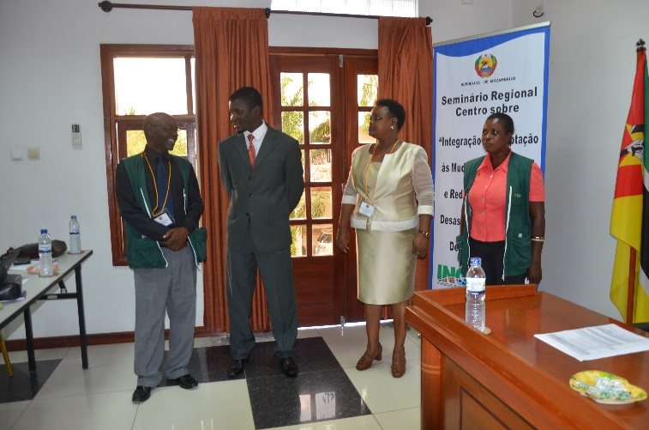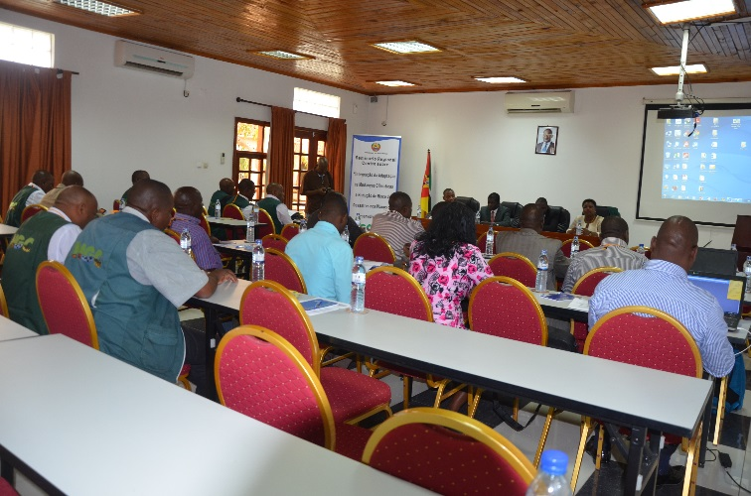**

**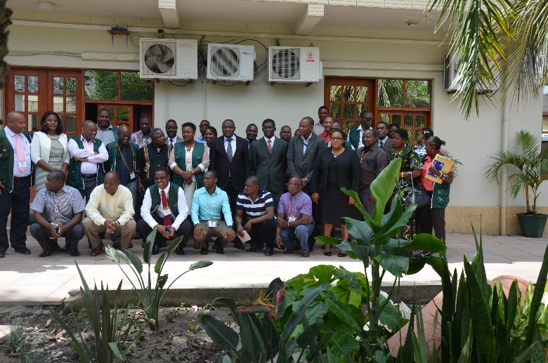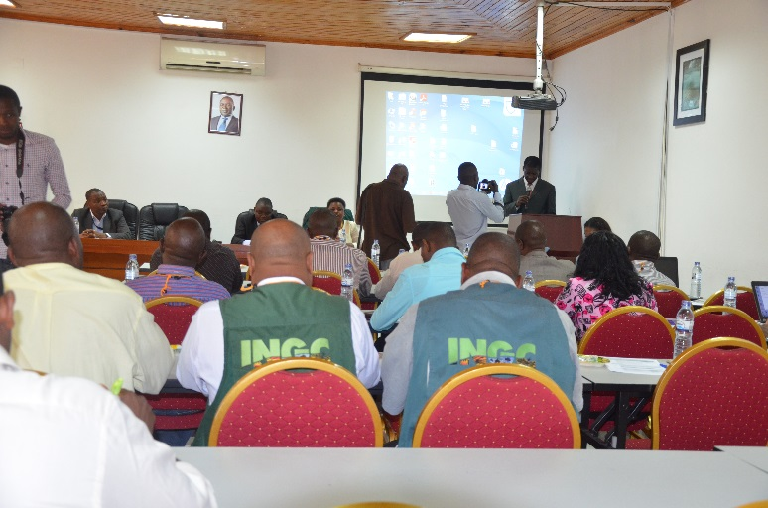**

**D) MADRID INITIATIVE: Cascading the MADRiD initiative in Nampula and Nacala; Novembro 16-19, 2015**

**Background**: This training was organised on the request of the governor of Nampula for district directors in the province, to ensure that they have the requisite skills on DRR/CCA mainstreaming. This was primarily due to the fact that directors did not have the opportunity to attend the first training organised for the province directors in July 8-10, 2015, and in his interaction with these district directors during one of the planning sessions, it was brought to his notice that the directors had no clue on DRR and CCA mainstreaming into planning the processes. To this end, he recommended that a training on DRR and CCA mainstreaming be organised for the directors. The training was conducted in two separate sessions for different target groups.

**Target:** Nampula Provincial Directors and selected technicians - total participants 34 (26 men & 8 women): These participants missed the first training organised in August as noted above.

Nacala District, Nampula Province – total participants 38 (32 men & 6 women): These are mostly district directors of planning and INGC staff.

**Objective of the training**

Sensitize provincial and district staff on the concept of integrating DRR & CCA measures into the planning of socio-economic development; and promote the establishment of a sustainable development of human resource capacity for integrated development planning

**Expected outcomes:**

* Consolidation of accessible technical resources for advancing DRR and CCA in development planning.
* Greater cooperation and coordination of efforts in mainstreaming climate change adaptation and disaster risk reduction into development at province.
* Strengthened government capacity on mainstreaming climate change adaptation and disaster risk reduction into development.
* Increased knowledge on the *dos and don’ts* of the DRR Law.

**Main areas covered included**: Framing on disaster & climate resilient development; Mainstreaming DRR & CCA into development; Climate information to enhance DRM; Risk Governance for disaster resilient development; Sectoral Mainstreaming at the provincial level; Spatial planning for urban settings; and DRR Law. Special attention was given to the following areas: mainstreaming of DRR and CCA in critical facilities –schools, hospitals, roads and railways; and in the agriculture and energy sectors. The Sendai Framework for DRR, 2015-2030, was also introduced to participants.

**Evaluation of the workshop**: Participants expressed appreciation of the workshop which came at the time of the beginning of the planning process for 2017. They noted, that the information will be very useful in ensuring the integration of DRR and CCA into their annual plans. They will share the information with their colleagues at work who never had the opportunity to participate. Due to limited number requested by the workshop planning team.

*Below are pictures showing some of the government officials and participants during the mainstreaming workshops:*

**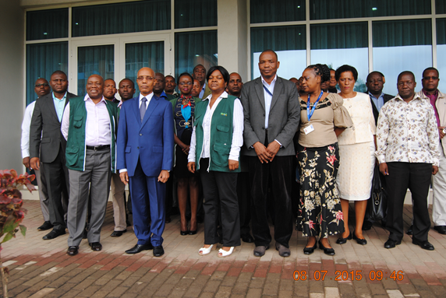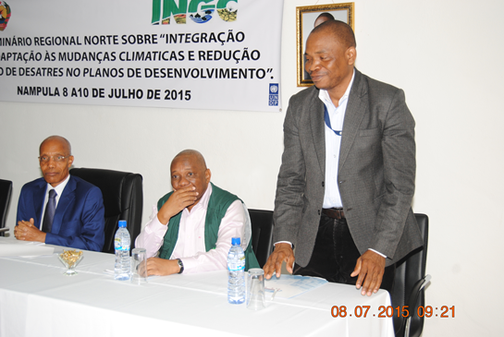**

ii) **Gender and DRR strategy**: Led by INGC, UN-Women and UNDP have drafted a Gender and DRR strategy which is currently awaiting government endorsement before printing. It is believed that if printed and disseminated will lead to addressing gender concerns in DRR interventions including responses.

1. A number of government staff have participated in UNDP/UNISDR **Madrid regional training programmes** which has increased their knowledge in support of the mainstreaming agenda.
2. **Documentary of best practices on DRR and CCA** was produced and approved by INGC. This is expected to further raise awareness among staff and development partners on the benefits in investing on DRR and CCA.

**Output 2**: **Disaster and climate risk information systems improved**

Activities undertaken under this output include:

i) ***Floods and cyclone risk assessment****:* Following the discussion and approval of the work plan with INGC the priority activity under this output is the floods and cyclone risk assessment in UNDP’s three priority provinces (Gaza, Nampula and Cabo Delgado). This was deemed necessary in order to have a comprehensive information on the level of floods risk in these three provinces to advance decision making processes. Funds from the SWISS was therefore allocated for this particular output.

Two consultants are currently working in some selected river basins in Cabo Delgado based on their initial mission assessment in the country, November 11, 2015. In this first mission, they have been able to define the needs and expectations of the project partners on the floods and cyclone risks assessment; setup national partners’ team; held meetings with key partners and data providers as well as launching the data collection process. They also visited some potential floods prone areas in Cabo Delgado where they had the opportunity to interact with local government institutions and communities and further fine-tuned the assessment methodology. At the moment, the consultants are working on a desk review and data analysis as recommended by the government which will lead to identification of gaps for further data collection and analysis. Final report of the work is expected to be submitted in February, 2016.

ii) ***Disaster loss database***: This has been established and updated with disaggregated data. The e-library created is now owned by INGC and is linked to the government website.

iii) ***Capacity building on climate information***: staff have been trained at both regional and local levels on climate information gathering to support analysis. Understandably, relevant information is currently being gathered and transmitted to the provincial and central levels to support decision making. Daily SMS messages are now being issued to alert the general public on the weather forecast in terms of rains and cyclones.

**Output 3: National and provincialsystems for recovery strengthened.**

3.1.3 Train national and local authorities and other relevant partners on preparedness for recovery and PDNA

* A contextualised PDNA guidelines, including guidelines on gender has been drafted. National staff and local authorities and other relevant partners on the preparedness for recovery have been trained on the guidelines. The guidelines and training were very instrumental during the 2015 floods where the government, for the first time, took the lead in the recovery processes with UNDP back-stopping.
* Two staff had the opportunity to participate in one regional PDNA training in Nairobi. The knowledge acquired is expected to cascade to colleagues in the country. One of trainees is from the planning department of the Ministry of Economy and Finance who has embraced the PDNA process,
* More training is required to ensure that the skills and ownership of the recovery processes in any given disaster at all levels as this tool is proven to be essential in evaluating damages and in building back better.

.

**Financial Information**

|  |  |  |
| --- | --- | --- |
| **Approved Budget** | **Approved Budget (USD)** | **Expenses (USD)** |
| BPPS | 500,000.00 | 365,338.50 |
| Swiss | 199,735.39 | 36,779.32 |
|  |  |  |

**Ongoing activities: January -September, 2016**

|  |  |  |
| --- | --- | --- |
| Activity | Date/Period | Status |
| 1. PDNA (Drought) | June TBD | Finalizing recruitment of consultant |
| 2.MADRID INITIATIVE: Cascading the MADRiD initiative in Maputo Province | July 20-22 | Work ongoing |
| 3. Floods and cyclone risk assessment | Contract signed with Swiss Consultants, work started for 63 working days | Work ongoing |
| 4. Seismic Training | August TBD | Finalizing recruitment of consultant for 21 working days |
| 5. Training for meteorological staff | July TBD | Work ongoing |
| 6. Two consultancies (tools for gender, civil society and private sector involvement on DRR&CCA, diagnostic study on DRR&CCA) | June-July | Work ongoing |